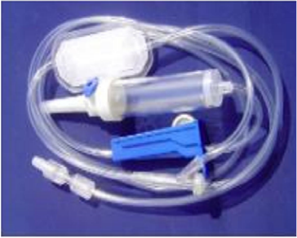 |  | MECCA HEALTHCARE PRIVATE LIMITED
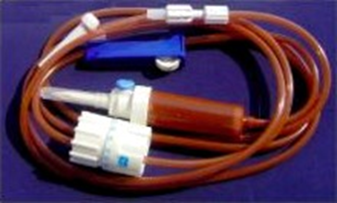

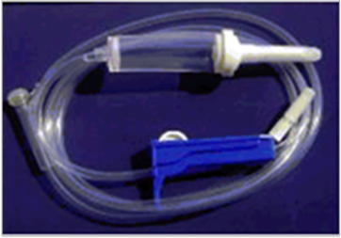
Since 1977


OUR VISION

To be an organization whose people & products exude Care, Compassion & Trust towards its users, business partners and society at large
OUR MISSION
Our mission is to be an organization whose employees strive for growth and values the contribution made by its founding members, through always keeping in mind the health and safety of the users of its products and thus satisfying the growing needs of the healthcare industry and its customers.

CONTENTS
Front Page 1
OUR MISSION 2
BRIEF NOTE ABOUT OUR COMPANY MECCA INDUSTRIES 4
INFUSION SETS 6
CATHETER 12
DISPOSABLE PERFUSION SETS 22
IV CANNULA 25
DISPOSABLE HYPODERMIC NEEDLES 28
CERTIFICATIONS 31
CONTACT US 32

BRIEF NOTE ABOUT OUR COMPANY MECCA INDUSTRIES
"Mecca Group of Industries", is a company set up in the year 1977 catering to the healthcare industry. Mecca Industries is among the first Indian company to begin mfg. Intravenous Infusion Equipments.
Our organization has three state of the art mfg. plants located at Kalol Dist; Gandhinagar & Chhattral Dist. Mehsana in Gujarat and Boranada Dist; Jodhpur, in Rajasthan.
Today we are an CE MARKED PRODUCTS, ISO 13485:2016 and WHO GMP compliant concern supplying to varied sectors of the healthcare industry in India. Recently Mecca has started developing 510K approval US FDA facility at its Kalol plant and intends to procure the certification by 2020.
Our products on an annual rate contract basis are supplied to State Governments of Gujarat, Madhya Pradesh, Maharashtra, Bihar and Tamil Nadu in India.
Mecca group is also exporting its CE marked products to all the CIS countries, Middle Eastern Nations, South East Asian countries, African Nations and Latin American countries since 1991 through contract manufacturing and merchant export.
We are also working on a loan license contract mfg. basis with Indian arms of two of the largest German companies of healthcare sector in the world, M/s. B. Braun Melsungen AG and M/s. Fresenius Kabi AG. Besides we are holding loan licence of Claris Otsuka Ltd (Formerly Core Parenterals associated since 1988). In past our co. has worked with almost all the Intravenous Infusion mfg. cos in India prominent being Sarabhai Industries, Cadila Pharmaceuticals, Tide Pharmaceuticals (a unit of Torrent Pharma.), Wockhardt Pharma, Intas Pharmaceuticals, Cipla Limited, Albert David Ltd. et al.

To know more about our organization and its line of work we suggest you visit www.mhplindia.com.
Mecca Healthcare (P) Limited, INDIA
Plant Address;
UNIT - 1, 99 - 102, GIDC, KALOL (N.G.), Dist; Gandhinagar, Gujarat
UNIT - 2, L-1202, GIDC Chattral, Dist.; Mehsana, Gujarat
UNIT - 3, F-252, III Phase, Boranada, Jodhpur, Rajasthan
www.mhplindia.com / www.mhplindia.in
AN ISO 13485: 2016 & ISO 9001: 2015 and CE CERTIFIED COMPANY WHO GMP COMPLIANT MFG. PLANT further contact details available on page 31 of this catalogue.

INFUSION SETS

Lightproof Photosensitive IV Administration Infusion Set

(Micro Infusion Set)
Product Specifications
This Infusion set is prepared from Lightproof / Photosensitive polymer materials. Angiplast provides this Photosensitive sets available in Yellow and Brown color and are obtainable with or without Precision Flow Controller [Dial Type] 5 mi to 250 mli/hrs.
Features of our Lightproof Photosensitive Infusion Set:-
- Latex Free.
- Soft, Clear and Flexible Tubing.
- Sterile, Non-Toxic and Pyrogen-Free.
- Sterilized by E.0. (Ethylene Oxide)
88° TV Administration Set Vented, Vented Spike 20 Drops-ml with Guard/Brown Color Drip Chamber 60mm/Fluid Filter 15 Micron/ Flow Regulator/Precision Flow Controller 5-250ml-hr /Latex Free “y’-Site/Rotating Luer Lock Male Adaptor with Cap/3.0 x 4.imm PVC Tubing Brown Colour Length 304+1404+30cm/Sterile/Paper Poly Pack/ Quantities per Carton = 300 pcs
88° IV Administration Set Vented, Vented Spike 20 Drops-ml with Guard/Yellow Color Drip Chamber 60mm /Fluid Filter 15 Micron/ Flow Regulator/Latex Free Flash Bulb/Rotating Luer Lock Male Adaptor with Cap/ 3.0 x 4.1mm Yellow Color PVC Tubing Length 30+140+30cm/Sterile/Paper Poly Pack’ Quantities per Carton = 300 pcs.

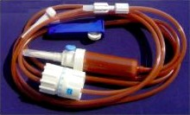

INNOVATIVE “AIR STOP” FEATURE KEY BENEFITS
- Avoids “Air Infusion” when IV Bottle gets empty & maintains a constant fluid level inside Infusion line so no air can get inside the patient body,
- Unique Technology "Precision-Filter” acts as a barrier for particulate matter 15 microns & below.
- Offers “No-Hassle”, “Risk-Free” & "Smooth Switch-Over” to next IV Bottle.

INNOVATIVE “PRIME STOP” FEATURE KEY BENEFITS
- “Auto Fill” of Infusion Set with “No Dripping” of IV Fluid on hands, floors & bedding at time of IV Infusion.
- Offers ease in Multiple Solution preparations and saves time.
- Maintains a closed system before the commencement of IV Therapy to a patient.

- Fitted with Safety Roller Controller offering secure disposal of IV Set after use.
- Fitted with Rotating Luer Lock for easy fitment to an IV Catheter.
- Fitted with a Slip Clamp offering ease in temporary stop-over of IV Therapy.
- Fitted with a Y-Site for Extra Medication.

KEY BENEFITS Mecca Normal

IV Set IV Set
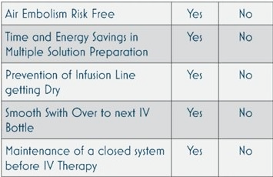
A Technical Collaboration with ACME UK Inc. Limited, London, Great Britain.

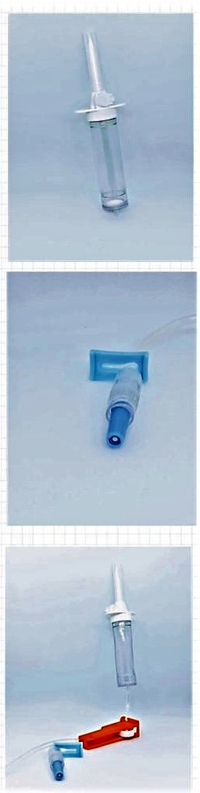

- 84” IV Administration Set Vented, Vented Spike 20 drops-ml with Guard//Drip Chamber 700mm/Fluid Filter 15 micron/Flow Regulator’ Dial Flow Regulator! Latex Free ‘Y'-Site/0.2 Micron Filter/Rotating Luer Lock Male Adaptor with Cap/ 3.0mm x 4.1 mm PVC Tubing-Length 60+50+30+15cm/E0 Sterile/Paper Poly Pack Quantities per Carton = 300 pcs
- it-01a1 82" IV Administration DC Non-Vented, Non-Vented Spike 10 drops-ml with Guard/Drip Chamber 70mm/Flow Regulator/Latex Free ‘Y’ Site/0.2 Micron Filter/Rolling Luer Lock MaIe Adaptor win Cap/3.Omm x4.1mm PVC Tubing-Length 115+30+15cm/EO Sterile/Paper Poly Pack / Quantities per Carton – 300 pcs
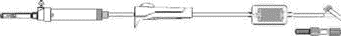
- 82” IV Administration Set Vented, Vented Spike 20 drops-ml with Guard/Drip Chamber 70mm/Fluid Filter - -15 micron/Flow Filter/Latex Free 'Y'- Site/0.2 Micron Filter/Rotating Leer Lock Male Adaptor with Cap/ 3.Omm x 4.1mm PVC Tubing - Length 115+30+15cm/EO Sterile/Paper Poly Pack / Quantities per Carton = 300 pcs
- 12” Standard BDDA Extension Set, Female Luer with Cap/0.2 Micron Filter/Slide Clamp/Latex Free with/Rotating Luer Lock Stale Adaptor with Cap/3.0mm x4.1 mm RVC Tubing -Length 10+ 10+ 10cm/EO Sterile/ Paper Poly Pack / Quantities per Carton = 400 pcs
- 12” Standard BDDA Extension Set, Female Luer with Cap/1.2 Micron Filter/Slide Clamp/Latex Free with Site/Rotating Luer Lock Male Adaptor with Cap/3.0mm x4.1mm PVC Tubing -Length 10+10+10cm/EO Sterile/ Paper Poly Pack / Quantities per Carton= 400 pcs


Dial Flow IV Infusion Set

(Micro Infusion Set)

Product Specifications

Dial flow IV Infusion set comprises of a device that can be “dialed” to a specific infusion rate. They are ideally suited for gravity infusions and available in both vented (for bottles and bags) and non-vented (for Plastic bottles).
Some characteristics of our Dial flow IV Infusion set are:-
- Sharp spike for better penetration
- Reliable flow rate accuracy across the full adjustable scale Latex Free.
- Soft Clear Flexible Tubing.
- ASterile, Non-Toxic and Pyrogen
- Free Rotating Lock to simplify connection to patient.
- Pinch clamp to facilitate immediate shut- off when necessary.
- Custom configurations available upon request.

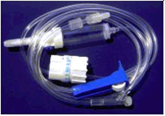
Vented Spike with Guard/20 drops-ml/Drip Chamber 60mm /Fluid Filter 15 micron/Flow Regulator! Dial Flow Regulators Latex Free ‘Y'-Site /Rotating Luer Lock Male Adaptor/ 2.7mm x 3.9mm PVC Tubing Length 504+130+15cm/E0O Sterile/Paper. Poly Pack / Quantities per Carton = 240 pcs.

Vented Spike with Guard/60 drops-ml/Drip Chamber 60mm/Fluid Filter 15 micron/Micro Drip Tube/Flow Regulator/Dial Flow Regulator/ Latex Free 'Y'- Site ‘Rotating Luer Lock Male <Adaptor/2.?7mm x3.9mm PVC Tubing-Length 50+130+15cm/EO Sterile/Paper Poly Pack / Quantities per Carton = 240 pcs
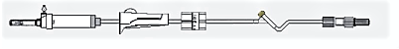



Infusion Set for Infusion Pump

(Micro Infusion Set)

Product Specifications
The device is efficient in pumping any liquid into our body. The tubing of the device comes in variable lengths to accommodate various needs.
- Some salient features of our Infusion set for Infusion Pump are as follows:-
- Available in vented (for bottles and bags) and non-vented (for plastic bottle
- Sharp spike for better penetration. 150 8536-4 compliant spike [50 5594/1 & ISO 594/23
compliant end-connection.
- Latex Free.
- Soft, Clear and flexible Tubing.
- Sterile, Non-Toxic and Pyrogen Free.
- Sterile Pack - ETO (Ethylene Oxide) Sterilization validate according to Harmonized Standards.

- 62" IV Administration Set Non-Vented, Non-Vented Spike 10 Drops-ml with Guard/Drip Chamber 60mm/Fluid Filter-15 micron/ Latex Free ‘Y' Site/Flow Regulator/Luer Tip Adaptor with Cap/3.0mm x 4.imm PWC Tubing-Length 135+15cm/EO Sterile/Paper Poly Pack / Quantities per Carton = 300 pcs
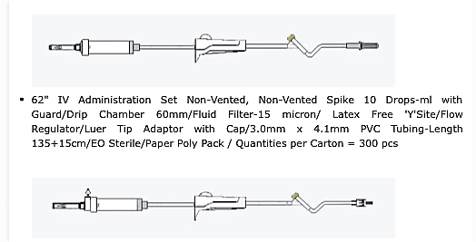

- 62" IV Administration Set Vented, Vented Spike 20 Drops-ml with Guard/Drip Chamber 7Omm/Fluid Filter-15 micran/ Latex Free ‘Y'-Site/Flow Regulator/Luer Lock Adaptor with Cap/3.0mm x 4.1mm PVC Tubing-Length 135+15cm/E0O Sterile/Paper Poly Pack / Quantities per Carton = 300 pcs


Paclitaxel Infusion Set

(Micro Infusion Set)
Product Specifications
Self and fast priming of adult set to curtail nursing. time. Automatic air-venting in any position loss of flow due to air locks. Able to withstand a minimum of 45psi (3.1 bar) pressure. ISO 8536-4 compliant Spike & ISO 594/1 and 594/2 compliant- end - connection. Bacterial retention for over 96 hrs.. Flow. Options available with PVC/DEHP - Free. Options available with Filter media 1.2 / 0.2 micron. EC). Sterile, Non - Toxic and Pyrogen Free.


76 Infusion for Paclitaxel Administration, Vented Spike 20 drops-nit with Guard/PVC¬DEHP- Free Drip Chamber 60m.m/ Fluid Filter 15mi.cron/Flow Regulator10.2 Micron Filter/Rotating Luer Lock Male Adaptor with Cap13.0mm x4.1rnm PVC-IDEHP Free Tubing-Length 140+15cm/E0 Sterile/Paper Poly Pack Quantities per Carton = 300 pcs

CATHETER
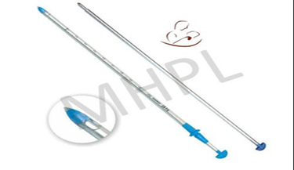

Chest Drainage Catheter With/Without Trocar
Usage/Application: Hospital
Material: PVC, HDPE, PP, SS
Is It Sterilized: Yes
Price Range – Rs. 24 to 74
Description: Catheter without Trocar: Atraumatic, soft rounded.
Open Distal end with six lateral eyes for non-traumatic insertion.
Catheter with Trocar: Atraumatic, soft rounded, Open Distal end with two lateral eyes for non-traumatic insertion. Cross side eyes to prevent tissue aspiration
Additional Information:
Length: 30 -60 cm
Available Sizes: FG 20, 22, 24, 26, 28, 30, 32, 34, 36, 38, 40
Peritoneal dialysis catheter (Curled)
Usage/Application: Hospital
Material: silicone rubber
Is It Sterilized: Yes
Pricing Range: over 300 to 9000 per set
Packaging Type: Poly Pack
Description: The peritoneal dialysis catheter is composed of a flexible silicone tube with an open-end port and several side holes to provide optimal drainage and absorption of the dialysate. The extraperitoneal component of the catheter has either one or two Dacron cuffs. The Dacron cuffs are for optimal ingrowth and fixation.

Length: 57/62 cm²
Cuffs Type: Curled Outer
Diameter: 15Fr
Available in the lengths of 57 cm and 62 cm


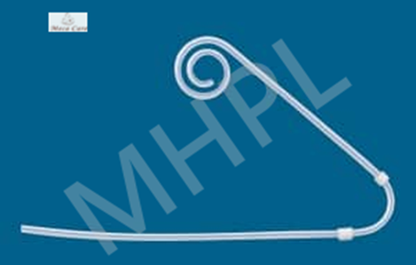
Tracheobronchial Suction Catheter

Usage/Application: Hospital
Material: PVC, Polystyrene
Price: Rs 3-8
Description: Suction catheters are medical devices that are used to remove
bodily secretions from the trachea and bronchial region of a person.
Anti Crush Tube: Yes
Color: Transparent
Packaging Type: Packet
Is It Sterilized: Sterilized
Is It Disposable: Disposable
Tube: Radio opaque, soft, kink free non toxic PVC tube.
A traumatic soft rounded, beveled open tip with one lateral eye
Colour coded plain connector for easy identification of size
Length: 53 Cm
Size: FG 8, 10, 12, 14, 16, 18

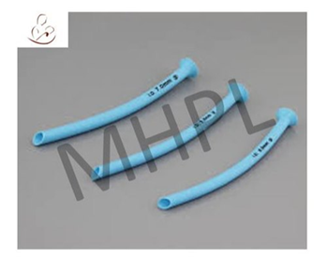
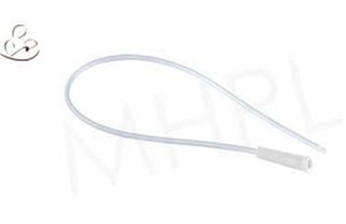
Nasopharyngeal Catheter

Usage/Application Hospital
Material: PVC, Polystyrene
Description: A nasopharyngeal airway, also known as an NPA, nasal trumpet
(because of its flared end), or nose hose, is a type of airway adjunct, a
tube that is designed to be inserted into the nasal passageway to secure an
open airway.
Price : 105 - 180
Is It Sterilized: Sterilized
Color: Light Blue
Packaging Type: Packet
These are made from soft, non-irritant medical grade PVC
Airways are anatomically designed with smooth round edges, thin wall and kink resistance for maximum patient comfort
E.T.O. sterile & pyrogen free. Nasopharyngeal Airways are disposable and for single use only.
Suction Tip & Catheter

Usage/Application Hospital
Material Type Plastic PVC
Description: A suction catheter is a medical device used to extract bodily secretions,
such as mucus or saliva from the upper airway.
Price: Rs 5
Tube: Radio opaque, soft, kink free non toxic PVC tube.
A traumatic soft rounded, beveled open tip with one lateral eye
Colour coded plain connector for easy identification of size
Length: 53 Cm
Size: FG 8, 10, 12, 14, 16, 18
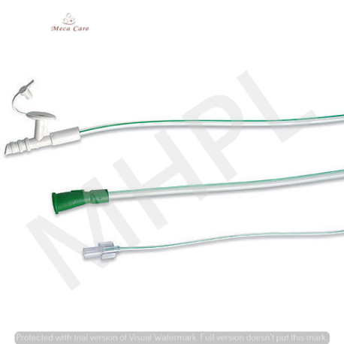

Angiographic Catheter
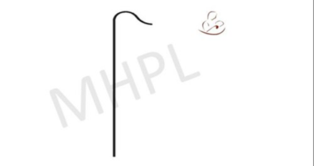
Usage/Application: Hospital
Material: Plastic
Description: The angiographic catheter is a plastic tube which functions as a conduit for
contrast, fluids,and pressure measurement during cardiac catheterization of coronary arteries
and the left ventricle
Price: 900 per packet
Length 100 cm
Is It Sterilized: Sterilized
Disposable: Yes
Thickness: 0.038 Inch
Specifications
Material = Polyurethane
Braiding = Single wire
Hub = Winged


Hemodialysis Catheter

Usage/Application: Hospital
Material: Silicone
Is It Sterilized Sterilized
Description: A dialysis catheter is a catheter used for exchanging blood to and
from a hemodialysis machine and a patient.
Price 1200/ pc
Product Specification
Size: 11.5Fr & 12FR
Lengths of 13.5-20cm.
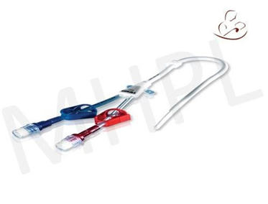
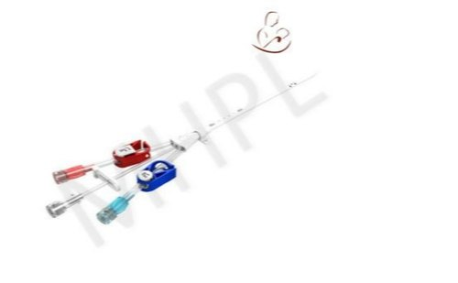
Multiple Lumen Catheter

Usage: Hospital
Is It Sterilized: Sterilized
Disposables: Yes
Material: PU
Size Fr12-Fr26 / 14 - 30 cm
Price: 1350-2000/pc
Description: A multi-lumen catheter is a single catheter with more than one internal channel (called a lumen). A different intravenous infusion can be connected to each lumen, and the fluid will usually exit at a slightly different point along the catheter
Basic Set Contains ( Seldinger technique Insertion set)
Radiopaque Polyurethane Catheter
Vessel Dilator
Y-shape Introducer Needle ( 18G x 7cm)
One Injection cap per lumen
Optional suture loop with box clamp
0.035” x 60cm guide wire with straight and J-tip and guide wire insertion devices 5ml syringe with 22g Needle.



Intramuscular Pressure Monitoring Catheter
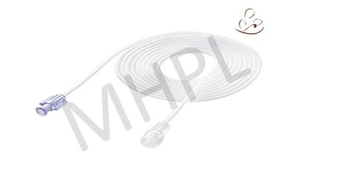
Application: Hospital
Color: Transparent
Material: PVC
Length:10 cm 0.50 ml 25 cm 1.40 ml 50 cm 2.90 ml 100 cm 5.90 ml 150 cm 8.90 ml
Price: 12 - 23
Description: It monitors the fluent blood pressure accurately and used for the
connection between patient and syringe infusion pump.

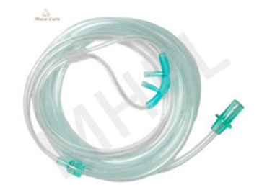
Nasal Oxygen Catheter
Price: 13 to 30
Sizes FG 8,10,12,14
Usage Hospital
Packaging Type Single Piece in PE Pouch
Application: For administration of oxygen for nasopharyngeal route
Tube Length 40 cm
Material: PVC
The nasal cannula (NC) is a device used to deliver supplemental oxygen or increased airflow to a patient or person in need of respiratory help. This device consists of a lightweight tube which on one end splits into two prongs which are placed in the nostrils and from which a mixture of air and oxygen flows.

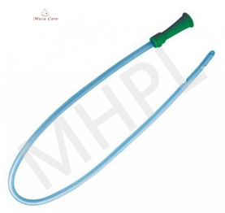
Urethral Catheter/Nelaton Catheter/Foley Catheter
Material: PVC
Description: Ureteral Catheters are indicated for use for catheterization of the urinary
tract during interoperative. procedures,
Length: 400mm
Shape Funnel shaped
Size: FG 8,10,12,14,18,20,21 & 24.
Price: Rs 4 to 35

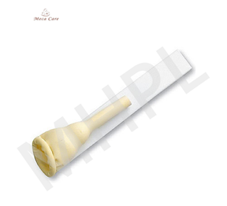
Urethrographic Male Catheter

Usage Hospital
Material: PVC
Size 20mm-35mm
Price: NA
Descripion: In Descending Urethrography, a urinary catheter will be placed to
your bladder to fill up the bladder with a solution containing contrast medium
and then the catheter is removed.

Feeding Tube
Usage: Clinical Purpose, Veterinary Purpose, Hospital
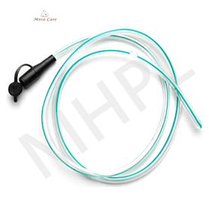
Material: PVC
Price: Rs 3.6
By leveraging our extensive market knowledge, we provide the best quality assortment
of Infant Feeding Tube.
Product Specifications:
Sterile Non Toxic and Pyrogen free.
Smooth, non-toxic, non-irritant, flexible, medical-grade PVC tube.
Siliconized and smooth with rounded outer surface finish for minimal tissue irritation.
Thermo sensitive material-softens at body temperature to confirm to internal anatomy.
Transparent ease of checking for obstruction
Molded tips and eyes
X-ray visible full-length radio-opaque line
Poly bag packing
ETO sterilization
Easy and aseptic removal from package
Size (FG): 5,6,7,8,9,10


Tracheostomy Tube/Tracheal Tube
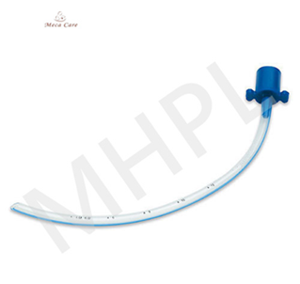
Usage/Application: Hospital
Material: PVC, Polystyrene
Description: A high-volume, low-pressure cuff provides an air tight fit between tube and
Trachea offering typical inflation near the distal tip of the tube to help secure it in place
and protect the airway from blood, gastric contents, and other secretions.
Sizes : 2.5 mm to 5.0 mm
Price Range: 20 - 40/15M
Gas Monitoring Port: Yes
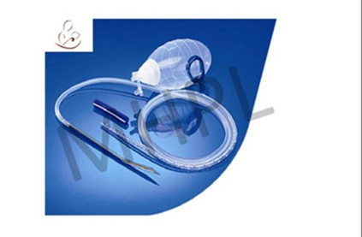
Closed Wound Drainage Tube or System

Usage/Application: Hospital
Material: PVC, S.S, ABS, LDPE, HDPE
Description: Intended for evacuation of biological fluid from wound or body cavity during
surgical procedure or in wound care management.
A closed suction drain is removes fluids that build up in areas of body after surgery or
when one has an infection.
Price: 99 to 132
Available Size: FG 6, 8, Adult FG 10, 12, 14, 16, 18

Heart Lung Bypass Unit Tube
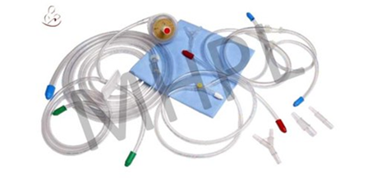
Usage/application: Hospital
Material: Silicone/Rubber/PVC
Is it sterilized: Yes
Market price range: NA
Description: A tube will be placed in your heart to drain blood to the machine.
This tubes series of tubes made of silicone rubber or PVC

Urinary Drainage Unit

Usage Hospital
Material: PVC
Type: Poly bag
Price: 12.8
Description: We are actively engaged in offering a qualitative range of Carrying Urine
Collection Bag for catering the diversified requirements of our clients.
Specifications:
Packing: (10 Pcs in a Polybag) x (25 such bags in a carton) =250 Pcs per carton
Packing: (10 Pcs in a Polybag) x (25 such bags in a carton)=250 Pcs per carton
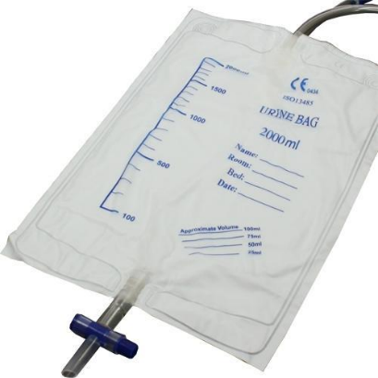

Ryles Tube
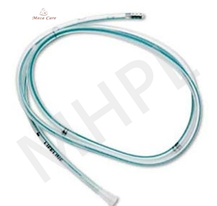
Usage/Application: Hospital
Material: PVC
Is It Sterilized: Yes
Price Range – Rs. 11.70
Description: It is special tube that carries food and medicine to the stomach through the nose.
It can be used for all feedings or for giving a person extra calories.
Material: PVC,PP
Is It Sterilized: Sterilized
Usage Clinical, Hospital
Size/Dimension: FG 08, 10, 12, 14, 16
Color Transparent



Single Needle Hemodialysis Catheter/Blood Lines

Usage: Hospital
Is It Sterilized: Sterilized
Price: 200 - 650
Material Type: PVC,LDPE, Polycarbonate
Description: Hemodialysis is a treatment for kidney failure that uses a machine to send
the patient’s blood through a filter, called a dialyzer, outside the body. The access is a
surgically created vein used to remove and return blood during hemodialysis. The blood
goes through a needle, a few ounces at a time. The blood then travels through a tube
that takes it to the dialyzer.
Priming Volume: 0.20 ml
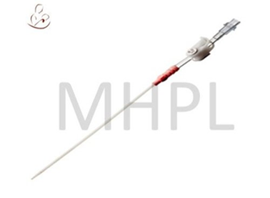

Tonsil Suction Tube
Usage/application: Hospital
Material: pvc
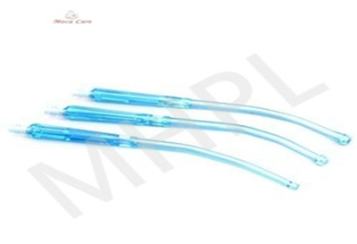
Description: The Yankauer tonsil aspirator is used for precision suction in the oral cavity
and pharyngeal area to remove blood, saliva, and fragments of tissue and bone. The end
of the suction is rounded to be gentle on soft tissue with suction holes located on the sides.
The round end detaches for easy cleaning.
Price Range: Rs. 30-40
It is Disposable: Yes
Tube Length: 210 cm, 250 cm and 300 cm.
Details:
• Anti-broken materiel
• Available with Crown lip and Plain tip, Latex free, Crown tip, With slid vent, Crown tip, With vent, Crown tip, Without vent, Crown to. With slid vent, 1.8m Suction tube, Crown to. With vent, 1.8m Suction tube, Crown tip, With 1.8m suction tube, without vent, Plain tip with vent, Plain tip, without vent


Needle Free Connector

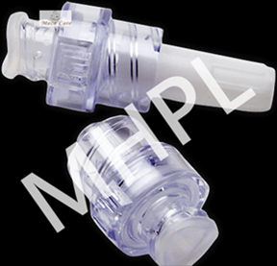
Usage/Application: Hospital
Material: Polypropylene
Is It Sterilized: Yes
Price Range : 20 to 42
Description: Needleless connectors (NCs) are essential devices which connect to the end
of vascular
catheters and enable catheter access for infusion and aspiration.
Additional Description:
PVC Tube Length 10 - 300 Cm
Specifications and models - PV-I straight form structural composition - interface, a joint,
a piston and a silicon spring
Type - Positive Pressure Type
Length of Extension Tube - 10-30cm
Usage - Blood Dialysis Treatment
Injection site: Silicone
All materials are latex-free and DEHP-free



Disposable Perfusion Sets

3way Stopcock as an Accessory to Perfusion Sets
Usage Clinical, Hospital
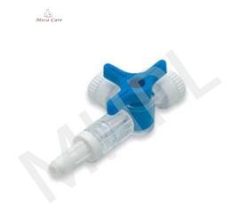
Use Single Use Only
Color Red, White, Blue
Price: Rs 11
Product Specifications
Manufactured from transparent polycarbonate/PE.
Inside is completely smooth & available with moulded luer lock.
Manufactured from non-toxic medical grade material.
E. T. O. Sterile and pyrogen free.
Color : Red/Blue/White

Heat And Moisture Exchange/Filter
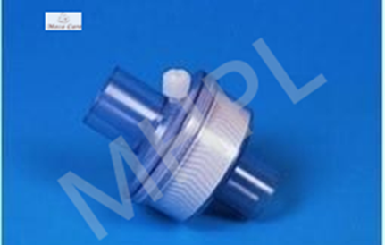
Usage/application: Hospital
Material: polypropylene
Is it sterilized: Yes
Market price range: Rs 50 to 350/ pc
Description: Heat and Moisture Exchangers (HME) are one type of commercial
humidification system, which also include non-heated-wire humidifiers and
heated-wire humidifiers.
Additional Information:
Moisture output: 32mg H2O/L
Filtration efficiency: 99.99%
Tidal volume range: 150-1500ml
Connections: 22M/15F - 22M/15M
Gas Monitoring Port: Yes
Available Sizes:

20g x 3.5" , 21g x 3.5" , 22g x 3.5" ,23g x 3.5" ,24g x 3.5" , 25g x 3.5" ,26g x 3.5" ,27g x 3.5"
Y Connector as an Accessory to Perfusion Sets
Usage: Hospital/ Clinical
Material: Polycarbonate
Description: Y-connector. a device in the shape of the letter Y that connects the end of one piece of tubing to two outlets
Color Transparent
Extension Tube: 20 cm
Price Range: 35 - 250
flow rate from 5ml / hr - 250 ml / hr manually.
Built-on "Y" Connector Injection site for extra Medication
Provision of male and female luer lock makes it compatible with other devices.
Available with DEHP Free Material.
Sterile / Disposable / Individually Packed


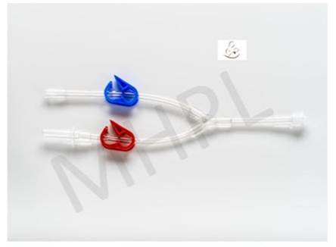

Manifolds
Usage/Application: Hospital
Material: Plastic, Polycarbonate
Is It Sterilized: Yes
Price Range: 180 to 240
Description: It provides 3-way flow (from inlet to outlet, inlet to side-port or side port to outlet) by use of the handle on the top of the stopcock to open and close lines. The device can also be used to reduce to lines down to one, for drugs/drug infusion
purposes and for the attachment of extension lines
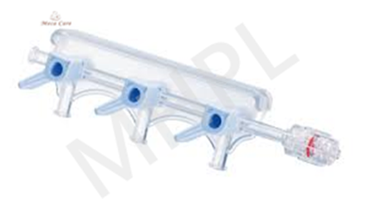
Additional Information:
Working Pressure: 250 psi, 500 psi, 800 psi
Sterilization: Ethylene Oxide
Port Size: 2 Port, 3 Port
Packaging Type: Packet
In addition, options include rotating luer and block body or half body styles.
Control Volume with large bore (.093"/.25cm) inner lumen throughout, including rotator
Control Ordering Option with 246 styles and pressure ratings of both 200 and 500 psi.
Control Operation with 6" (15.6cm) extended rotator.
Extension Sets
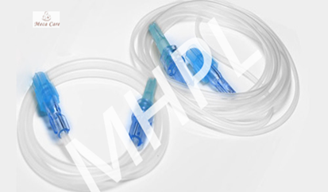
Usage/Application: Hospital
Material: Pvc
Is It Sterilized: Yes
Price Range: Rs 16- 40
Pack Type: poly pack/ box
Description: Extension sets are available with low pressure resistance designed
for infusion bags and high pressure resistance designed for infusion pumps.
The extension tubing prevents dislodgement of the catheter. It can be used to add length to existing tubing.
Additional Information:
Removable Sure-Lok® Needle-Free Connector
Pinch Clamp
Rotating Male Luer Lock
DEHP-free
Latex-free
Length: 8in
Priming Volume: 1.8mL

I.V. Flow Regulator.

Description. I.V. Flow Regulator used to accurately control & regulate the flow of I. V. Fluids. Using for the infusion of liquid substances directly into a vein.
Tube length 125cm
Price Range: 30 to 80
Usage Instruction: To use the rate flow regulator, simply dial the mL/hour. Smooth-moving translucent flow regulator dial w/ range of 5ml-250ml per hour.
Non-Latex and non-DEHP.
Packaged in individual blister packs

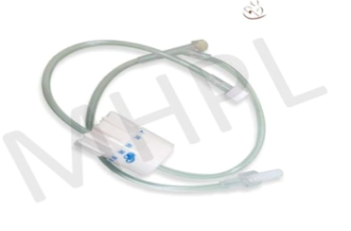



IV Cannula

Venous Cannula
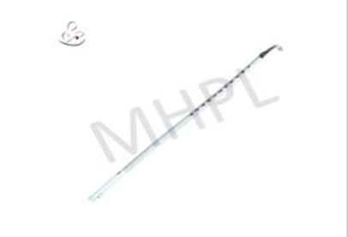
Usage/Application: Hospital
Material: Polypropylene
Is It Sterilized: Yes
Description: Intravenous (IV) cannulation is a technique in which a cannula is placed
inside a vein to provide venous access. Venous access allows sampling of blood, as well
as administration of fluids, medications, parenteral nutrition, chemotherapy, and blood products
Intravenous Cannula

Usage: Hospital, Clinic
Material : PVC
Price Range: Rs 4 to 7
Description: Intravenous (IV) cannulation is a technique in which a cannula is placed inside a vein to provide venous access. Venous access allows sampling of blood, as well as administration of fluids, medications, parenteral nutrition, chemotherapy, and blood products.
Product Specification
I. V. Cannula is designed with/without wings. It ensures painfree & smooth penetration.
- Non-toxic, biologically acceptable teflon made radiopaque shaft with metallic stillete.
- Injection port with one-way valve with flange attached to the catheter/shaft
- Standard size hub attached to the distal end for intravenous line attachment
- Injection port with colour-coded cap
- Colour coding for different sizes
- Transparent blister packing with tyvec paper.
E.T.O. Sterile & Pyrogen Free.
Length: 21 cm
Specifications: 28/36FR 30/38FR 32/40FR 34/46FR 36/46FR 36/51FR 38/46FR

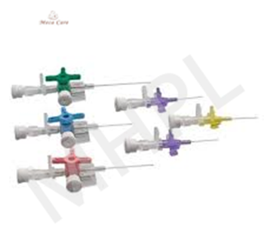
Arterial Cannula

Usage/application: Hospital
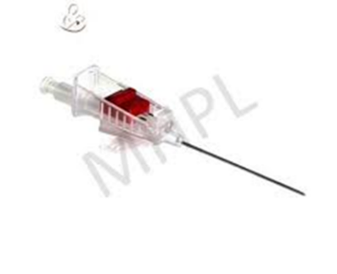
Material: PVC, PC, Sterlized steel
Description: An arterial cannula is inserted into an artery, commonly the radial artery,
and is used during major operations and in critical care areas to measure beat-to-beat
blood pressure and to draw repeated blood samples.
Price Range: Rs 1 to 6 per pc
Needle Material: SS
Packaging Type: Packet
Size: 10-22 mm

Coronary Artery Cannula

Usage/Application: Hospital
Material: PVC
Price Range: Not available
Description: Coronal Artery cannula are intended for use in delivery of cardioplegia solution
directly to the coronary arteries during cardiopulmonary bypass surgery
Packaging Type Poly Pouch
Is It Sterilized: Sterilized
Alternate name: coronary ostial perfusion cannula
Different configurations
- 45° or 90° tip
- 10 Fr, 12 Fr, 14 Fr
- length: 21cm
Features & Benefits
- basket tip
- malleable stainless-steel shaft

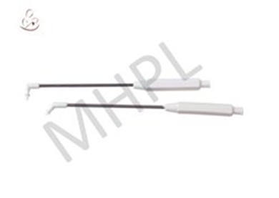


2

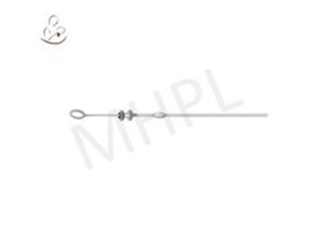
Ventricular Cannula

Usage/Application: Hospital
Material: Steel
Shape:ø2,5x90 mm
Description: For use in neurosurgical procedures. It is specially designed to penetrate
delicate brain tissue and give continued access to brain’s ventricular system.



Disposable Hypodermic Needles

Spinal Needles
Usage/Application: Clinic/ Hospital
Material: Stainless steel
Price Range: Rs 20 to 40
Is It Sterilized: Yes
Description: Spinal needles are used to inject analgesia and/or an aesthetic directly into the CSF
usually at a point below the second lumbar vertebra. Spinal needles enter the cerebral spinal
fluid (CSF) through the membranes surrounding the spinal cord.
Additional Information:
Length: 70
polycarbonate hub to offer easy visualization
length 3.5 inches
The Spinal Needle is available in 12 sizes: 16G X 3.5" , 17G X 3.5", 18G X 3.5" , 19G X 3.5",
20G X 3.5" , 21G X 3.5" , 22G X 3.5" ,23G X 3.5" ,24G X 3.5" , 25G X 3.5" ,26G X 3.5" ,27G X 3.5"
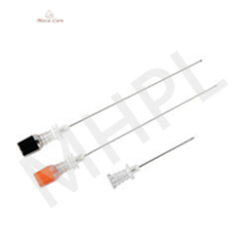

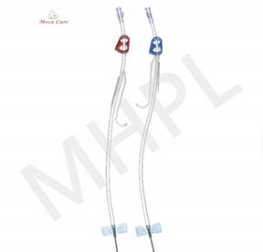
Fistula Needle
Usage/Application: Hospital
Material: Plastic
Is It Sterilized: Yes
Price Range: Rs 12 to 20
Description: A fistula cannula, fistula catheter, or plastic needle that is designed specifically for hemodialysis cannulation. The metal needle is used to access an AVF and to also guide the insertion
of the plastic sheath into the vessel.
Length 30 mm ; Size 15 g, 16g and 17 g
Outer Diameter: 1.40 - 1.90 mm
Relative humidity: Less than 80%

Features: Waterproof, Sterile
Angiographic Needle

Material: Stainless Steel
Usage/Application: Hospital
Brand: Mecca
Description: Angiographic needles have a unique hub design with an ergonomic
feel and a black triangle indicator to orient the bevel. Used for percutaneous
entry into vein. Griped Hub give better control. Used for angiography
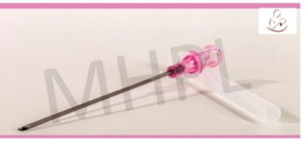




CERTIFICATIONS

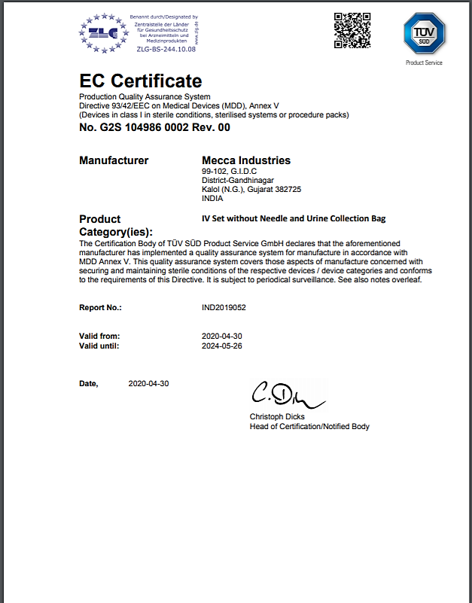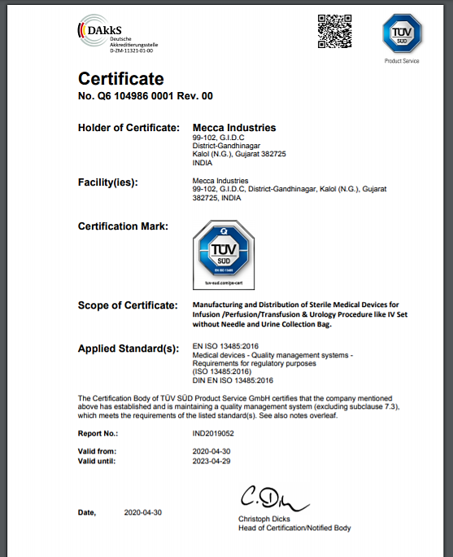

CE Certificate
Issue date: 30 April 2020
Expiry date:26 May 2024
ISO 13485:2016
Issue date: 30 April 2020
Expiry Date: 29 April 2023

CONTACT US

Corporate Office
Mecca Industries, B-605, Ratnakar Nine Square, Opposite ITC Narmada, Judges Bungalow Road, Near Mansi Crossroads, Vastrapur, Ahmedabad, Gujarat, India, Pincode: 380015
Tel; +91 79 4800 5989

Unit 1 Address
102, Mecca Industries Compound, G.I.D.C.Kalol (N.G.), Gandhinagar, Gujarat,India Pincode: 382725
Tel; +91 2764 221020

Unit 2 Address
F-252, III Phase, Boranada, Jodhpur,
Rajasthan, India, Pincode: 342012
Tel; +91 8320107430



Our UK Representative’s Address
ACME UK INC LTD
25 Leeming Road, Borehamwood, Hertfordshire WD64EB United Kingdom
Website: www.acmevision.com

Branch Office
L-1202, GIDC Chattral, Dist. Mehsana, Gujarat India

Regd. Office
408, Spectrum, Near G.P.O., Relief Road, Ahmedabad-01, Gujarat India

